Computer Language Coding Concepts

Related Items & Related Lists Collections
An object’s related items and related lists are actually stored as the object’s having two collections: Related Items and Related Lists. The Related Items collection contains all the related items of the object. The Related Lists collection contains all the related lists of the object.

The system members up until now were part of system objects like related item, related list or related list item. The members Related Items and Related Lists are not part of any of those system objects. Those members are part of the object itself. However, Related Items and Related Lists are considered system members.

Making Related Items and Related Lists part of a list, gives each related item and related list an ID in that list. A related item and related list’s system interface gets an extra member ID In Parent:

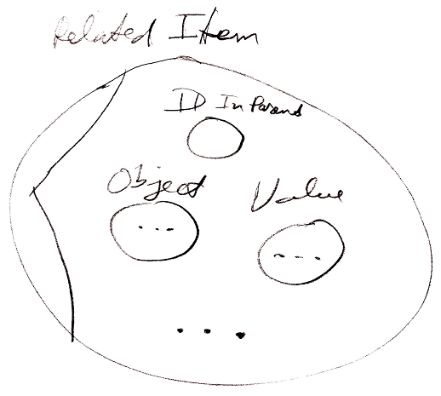

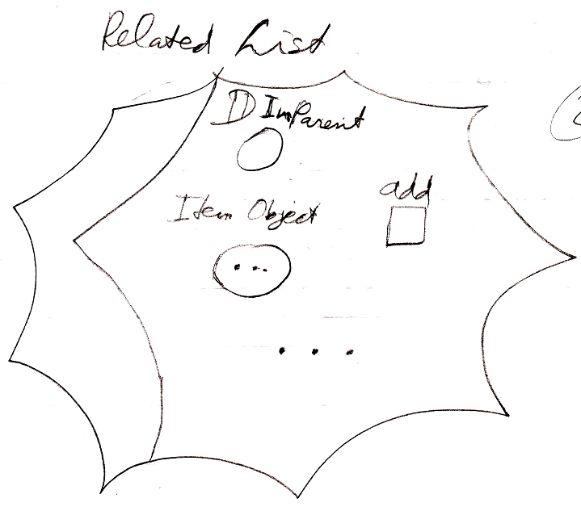

The related items and related lists collections are added to the system interface of the object itself:

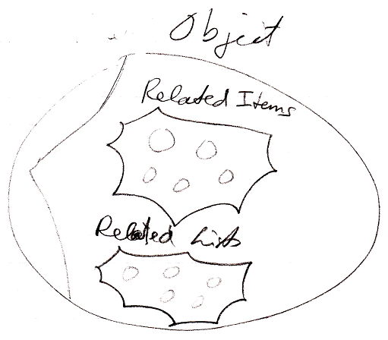

But an object itself is never shown in the diagram. You are always seeing related items or related list items, never the objects themselves. It is not clear yet whether to display the collections as part of the storage variable, that stores the object:

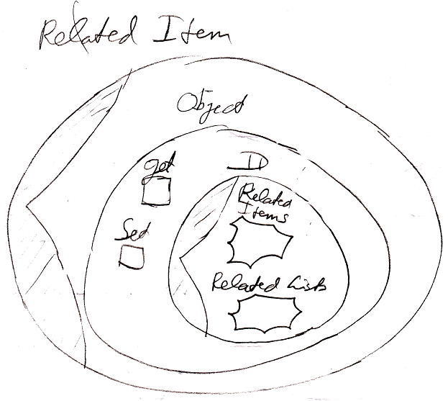

which is closest to how it physically works, or to just dump the two collections inside the system interface of a related item or related list item:

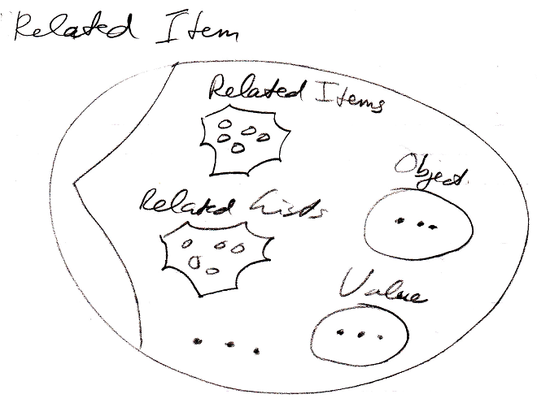

See also: System Objects

Author & Copyright: Jan-Joost van Zon Date: July 24, 2009 – July 24, 2008 Location: Oosterhout, The Netherlands Status: Finished

